Exercise 16
1. List ids, birth dates, and emails of employees born in April.
SELECT e_id, birth_date, p_email FROM employee_per WHERE MONTH(birth_date) = 4;
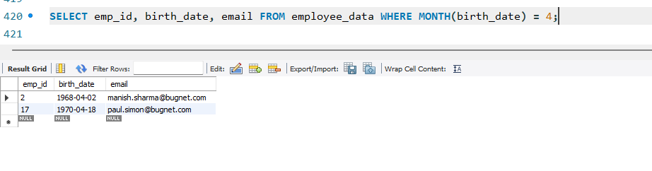

2. Display ids, birth dates, and spouse names of employees born in 1969, sorted by spouse names.
SELECT emp_id, birth_date, spouse_name
FROM employee_data
WHERE YEAR(birth_date) = 1969
ORDER BY spouse_name;
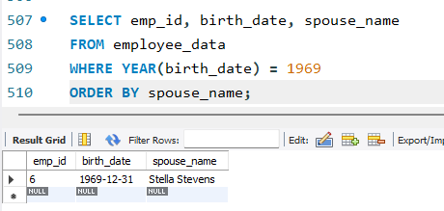

3. List the employee ids for employees born under the current month.
SELECT emp_id FROM employee_data WHERE MONTH(birth_date) = MONTH(CURRENT_DATE);
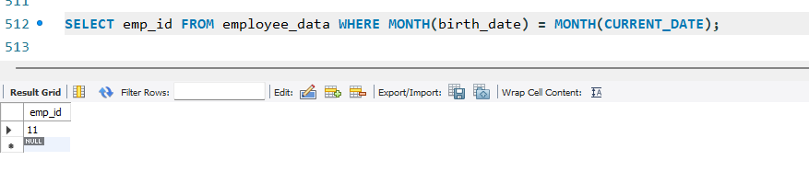
4. How many unique birth years do we have?
SELECT COUNT(DISTINCT YEAR(birth_date)) FROM employee_data;
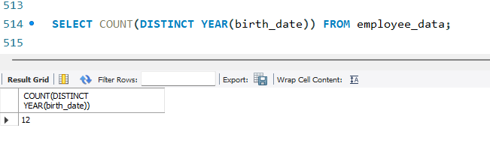

5. Display a list of unique birth years and the number of employees born under each.
SELECT YEAR(birth_date) AS birth_year, COUNT(*) AS emp_count FROM employee_data GROUP BY birth_year;
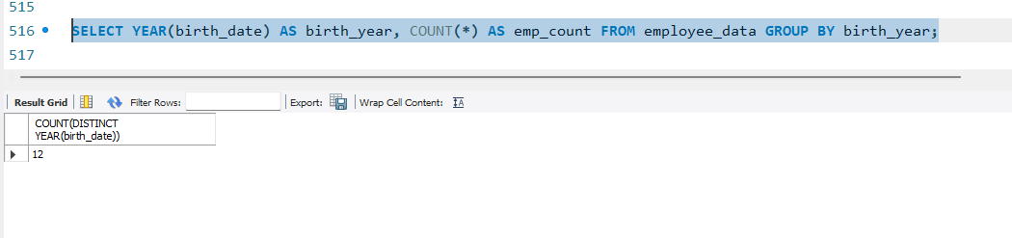

6. How many employees were born under each month? Display should have month names (not numbers) and sorted with the month having the largest number listed first.
SELECT MONTHNAME(birth_date) AS month_name, COUNT(*) AS emp_count
FROM employee_data
GROUP BY month_name
ORDER BY emp_count DESC; 